Minutes

Welcome, attendees and apologies
Welcome and introduction from Ange. Apologies from Bobby.

Review and approval of minutes of 7 March 2022
Comments on last meeting minutes (none) – Ange noted that if anyone had any comments they should send these direct to Bobby.

Chair’s report
Louisa noted that a significant amount of time since the last meeting had involved engagement on transitional arrangements with Michael and Karen (as well as the Accommodation Group). This had also included discussions around planning for future years at Comiston Road.
In addition, there had been discussions with the Council as well as around the remedial work on St Peter’s playing field that was needed.
Louisa also mentioned that £13,089 had been raised from the bake sale for Ukraine, with around £2,300 match funding provided, which was a brilliant effort and thanks to the Fundraising Team and all that helped.

Elaine Jones (planning to voice over presentation and share with parents)
Update on learning beyond the classroom. Trying to show where children are in community and outside space. Pre pandemic did a lot of visits to zoo, parliament etc. P5 Landrick Muir P7 Lagganlea

John Muir award – introduced in 2019 – not established as much as had wanted and looking to re-establish.

Post pandemic numeracy literacy and health and wellbeing (one third each) in August 2020. 98% of parents said children enjoyed outdoor learning and staff are now much more familiar and confident taking children out.

What next
City priority and SMPS priority to evolve the programme. High use of the playground but once a week use local parks / local areas. Social skills outdoor lessons was a key focus

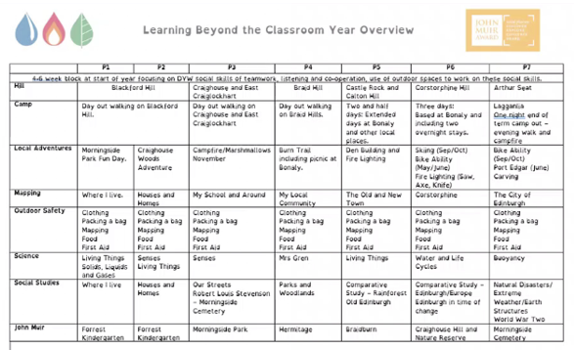

Seven hills challenge – where are we in our local area and introduction of local adventure days – den building, carving, fire lighting

Feedback from parents was good but would prefer to know what day things were happening so they could know what to send children in wearing.

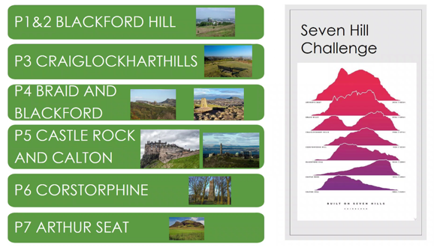

Clubs update

Ellie – Canaan Lane
Conversations have not progressed much further – CEC‘s plan is still to speak to parents with children in both schools and support will come from both schools (both HT’s).
Raise any issues with Canaan Lane group canaanlane@sm-pc.org

Neil Inglis – after school care club
Neil noted that there were some HR issues with North Edinburgh Childcare with Care inspectorate involved. The current transfer is on pause but it was emphasised that a long term solution is still needed.
There is work underway to ring fence a sizeable cash reserve held by SMASCC, so that funds would transfer to SMPC, if any future provider ceased trading.
Neil noted the Extraordinary AGM was due to take place on 12 May (note: subsequently cancelled).

Alistair – appointment of independent examiner of accounts – we now have 4 notes of interest. We will go in order of interest expressed. There are other things that others could do – we might ask more people to help treasurer (payments, paymaster, help with invoices etc). Other things – counting cash, Virgin money, fair – having more people to help is always welcome. All clubs are running at a surplus.

Chess club hope to return when we return to the school and Michael mentioned he still had chess sets in his office.

Transport – Gordon had meeting with Councillor Main about improving Greenbank Terrace
It was noted that now Pollution Monitor – installed
Green barrier installed

AOB
Claire Forsman noted that there parent consultations had taken place as well as a follow up questionnaire from the school around on these, she asked how parents might be more involved in these discussions, for example how we maximise the brief time available. (Note: need to pick this up before next meeting).

Cllr Neil Ross – Neil noted that the Council had followed up on his motion on low cost zebra crossings, which the Parent Council had provided a submission to. As a trial requires authorisation from the UK Government, in the meantime the Council will carry out their own investigation of existing low cost zebra crossings to gather evidence of their effectiveness for improving pedestrian safety.

Summer fair – still have high rates of covid so watching brief. It was re-iterated that the school had the highest Covid rates in the city for 2-3 weeks and that keeping classes in person had been the first priority, but that things were looking hopeful.

There was a discussion about the continued parking outside the school entrances, on double yellow lines or double parking. It was agreed that taking photos could be confrontational and that people might not be comfortable doing so. Mr Urquhart mentioned that he had written to parents about the issue. It was noted that park and stride was still seen as a good option, but that still might not deter / be a solution for certain parents.

